As a part of ingress demonstration, We are going to discuss below demos.
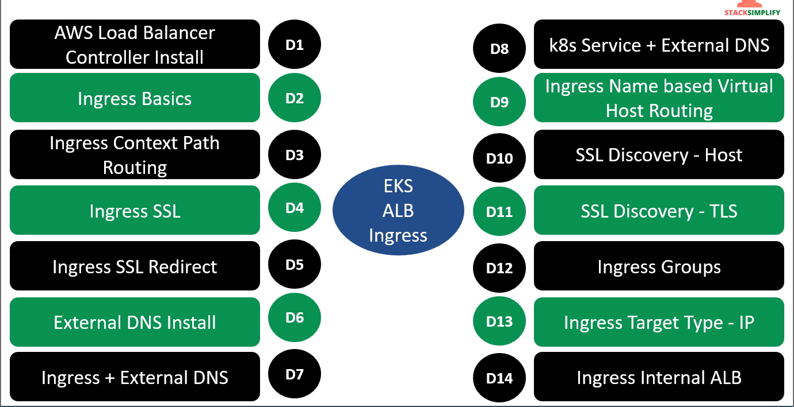
What is AWS ALB?
- ALB is super advanced, next generation LB in AWS.
- Support for Path-based Routing (/app1,app2,/usermgmt).
- Support for Host-based Routing (apps.kubeoncloud.com, users.kubeoncloud.com)
- Support for routing based on fields in the request (HTTP Headers, HTTP Methods, Query parameters and Source IP Address).
- Support for redirecting requests from one url to another.
- Support for returning a custom HTTP response.
- Support for registering Lambda functions as targets.
- Support for the load balancer to authenticate users of your applications through their corporate or social identities before routing requests.
- Support for containerized applications (AWS ECS).
- Support for monitoring the health of each service independently, as health checks are defined at the target group level.
- Support for registering targets by IP address, including targets outside the VPC for the load balancer.
ALB Ingress Controller (ALBIC):-
- ALBIC triggers the creation of an ALB and the necessary supporting AWS resources whenever an Ingress resource is created on the cluster with the kubernetes.io/ingress.class: alb annotation.
- The ALBIC supports two traffic modes 1. Instance 2. IP
- Doc ref: Welcome - AWS Load Balancer Controller .
- Instance Mode
- Registers nodes within your cluster as targets for the ALB.
- Traffic reaching the ALB is routed to NodePort for your service and then proxied to your pods.
- This is the default traffic modes.
- You can explicitly specify it with the alb.ingress.kubernetes.io/target-type: instance annotation.
- IP Mode:
- Register pods as targets for the ALB.
- Traffic reaching the ALB is directly routed to pods for your service.
- You must specify the alb.ingress.kubernetes.io/target-type:ip annotation to use this traffic mode.
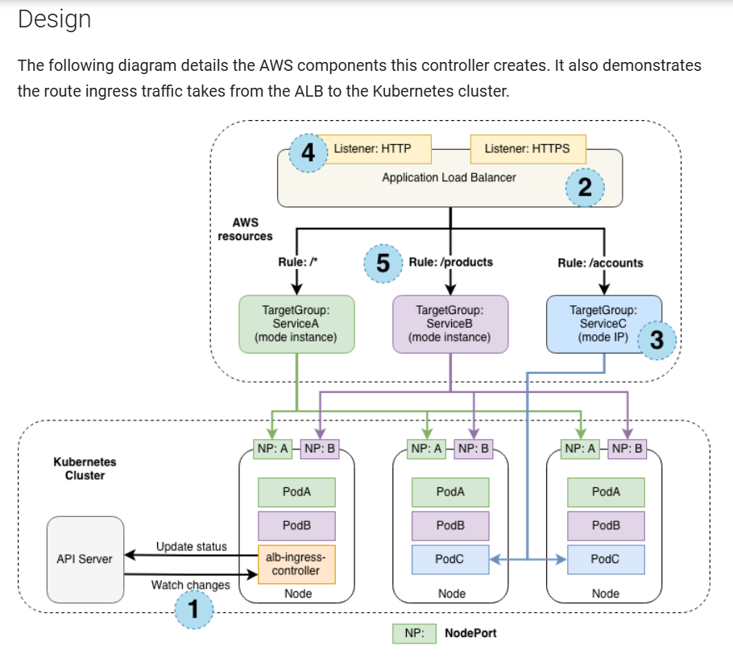
Note:- The controller manages the configurations of the resources it creates, and we do not recommend out-of-band modifications to these resources because the controller may revert the manual changes during reconciliation. We recommend to use configuration options provided as best practice, such as ingress and service annotations, controller command line flags and IngressClassParams.
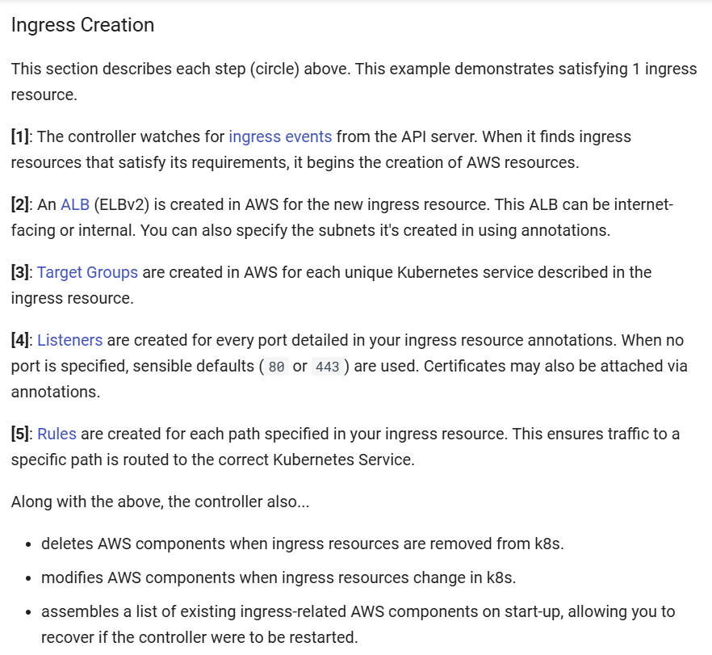
Doc:- How it works - AWS Load Balancer Controller
Install LB Controller:-
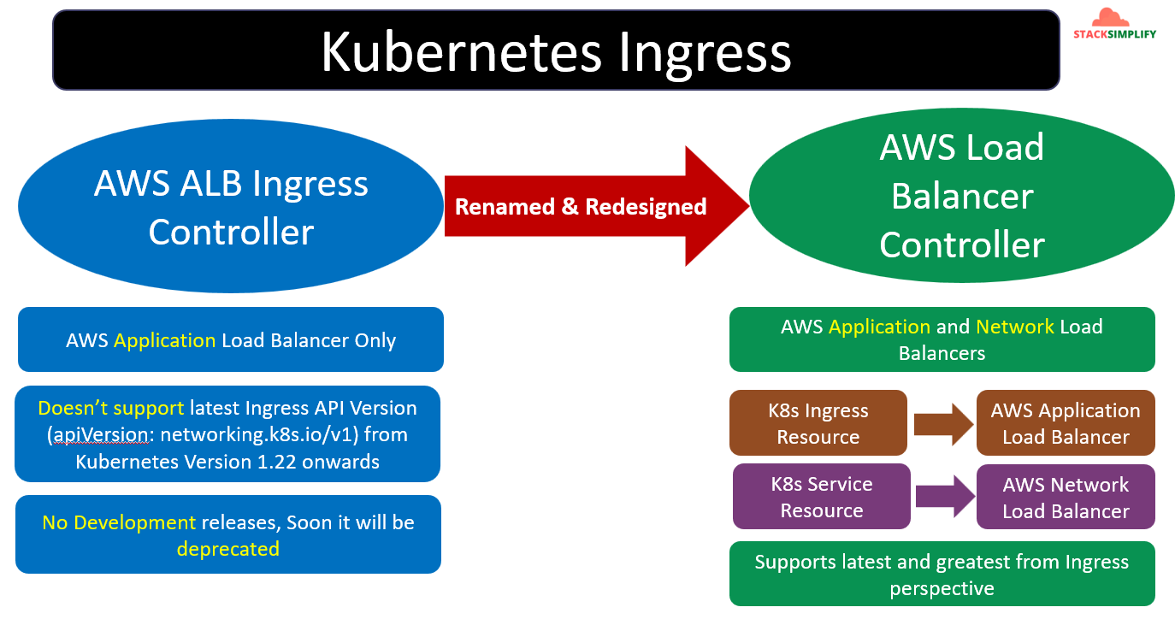
We know whenever we define ingress configuration of the resources the AWS Load Balancer Controller will look for that event and create it. To do happen this process we have to see in detail configuration of each.
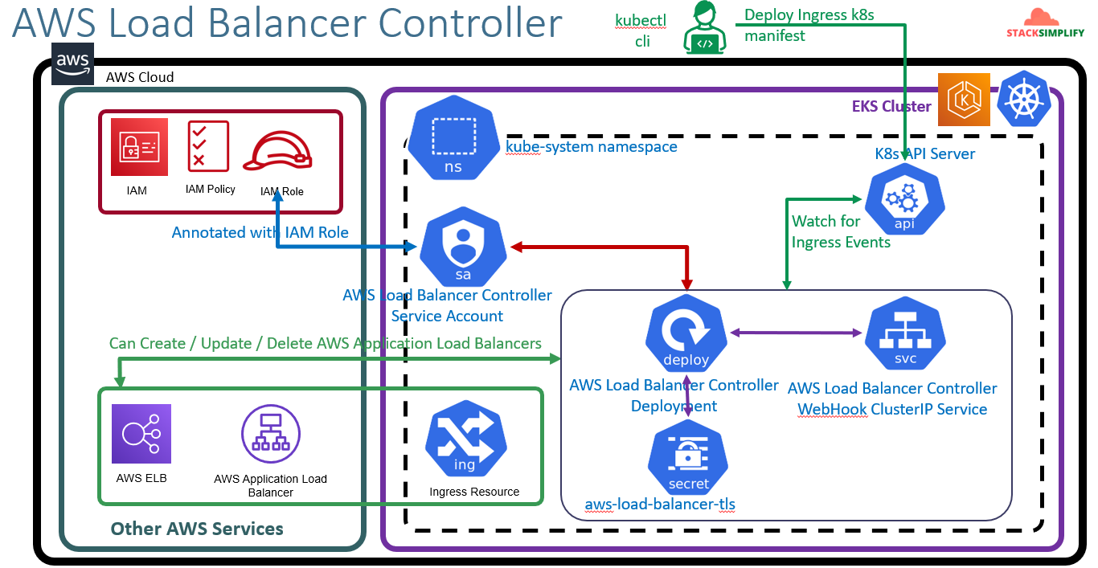
From above image if you see we have 2 partitions one is AWS cloud and another one is EKS Cluster.
Step1:- We will create the AWS LB controller Service Account in K8s then we will create IAM policy and the IAM role and this IAM role will be annotated inside the Service Account.
Step2:-Whenever you deploy the LB controller it will create the deployment with PODS related to LB controller in addition to it will create AWS LB Controller WebHook ClusterIP Service and aws-load-balancer-tls.
Step3:-The Service account will be associated with AWS LB controller Deployment.
Step4:- The user using kubectl cli going to deploy Ingress K8s manifest the LB controller will watch for the Ingress events through K8s API Server.
Step5:- The AWS LB Controller will get the Ingress K8s manifest and going to create the ALB and in K8s you can see it as Ingress resource from above pic.
Note:- We have AWS LB controller Deployment means we are having the PODs. Those PODs are worke loads in our EKS cluster. Those work loads will create the AWS service called ELB. It all happens based on the permission we given to LB controller. We have given IAM permission to create/delete/update the ALB in AWS LB Controller Service Account by using this permissions the LB controller will create the ELB.
Pre-requisites:-
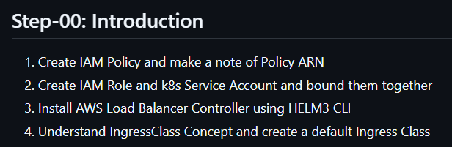
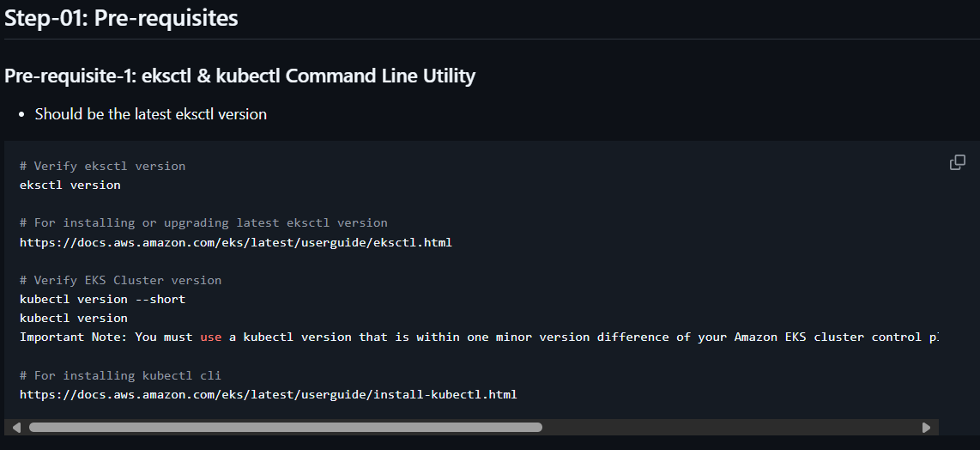
If cluster is not created create it.
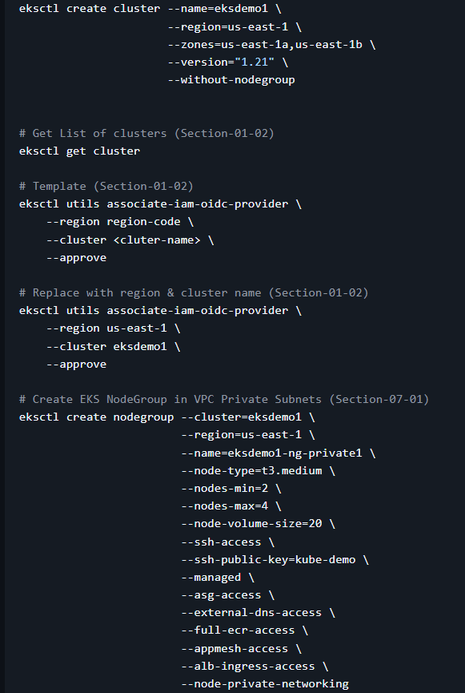
To reduce billing I have created single node.
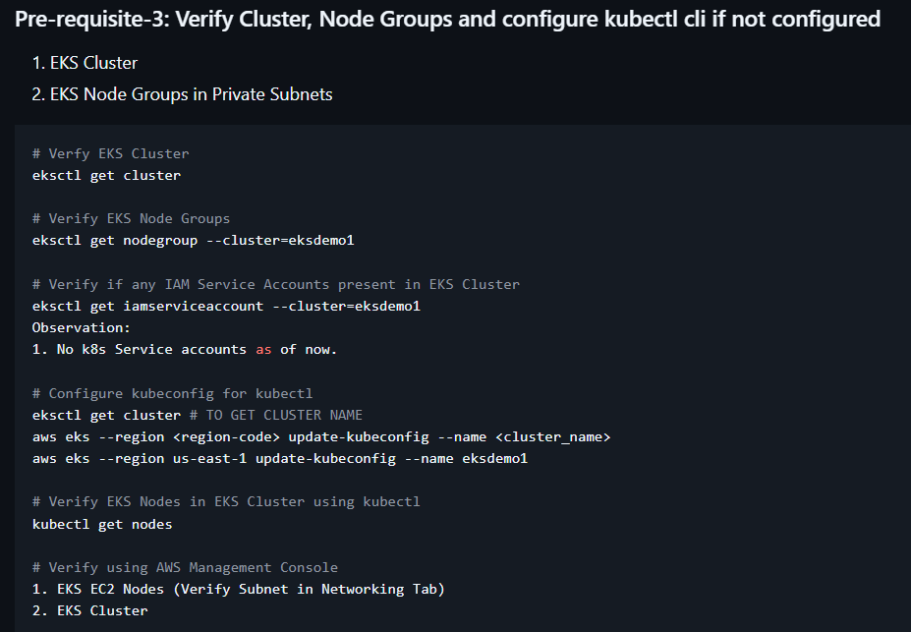
Pre-requisites are verified now we are moving to create IAM Policy.
Creation IAM Policy:-
Doc:- https://github.com/stacksimplify/aws-eks-kubernetes-masterclass/tree/master/08-NEW-ELB-Application-LoadBalancers/08-01-Load-Balancer-Controller-Install#step-02-create-iam-policy
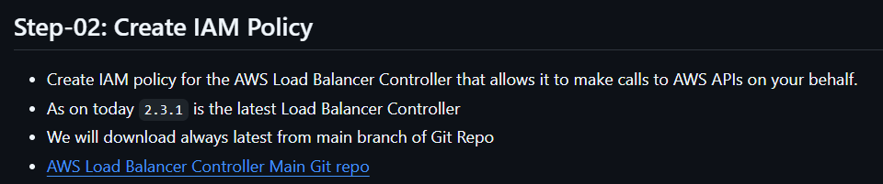
AWS LB controller Git repo kubernetes-sigs/aws-load-balancer-controller: A Kubernetes controller for Elastic Load Balancers
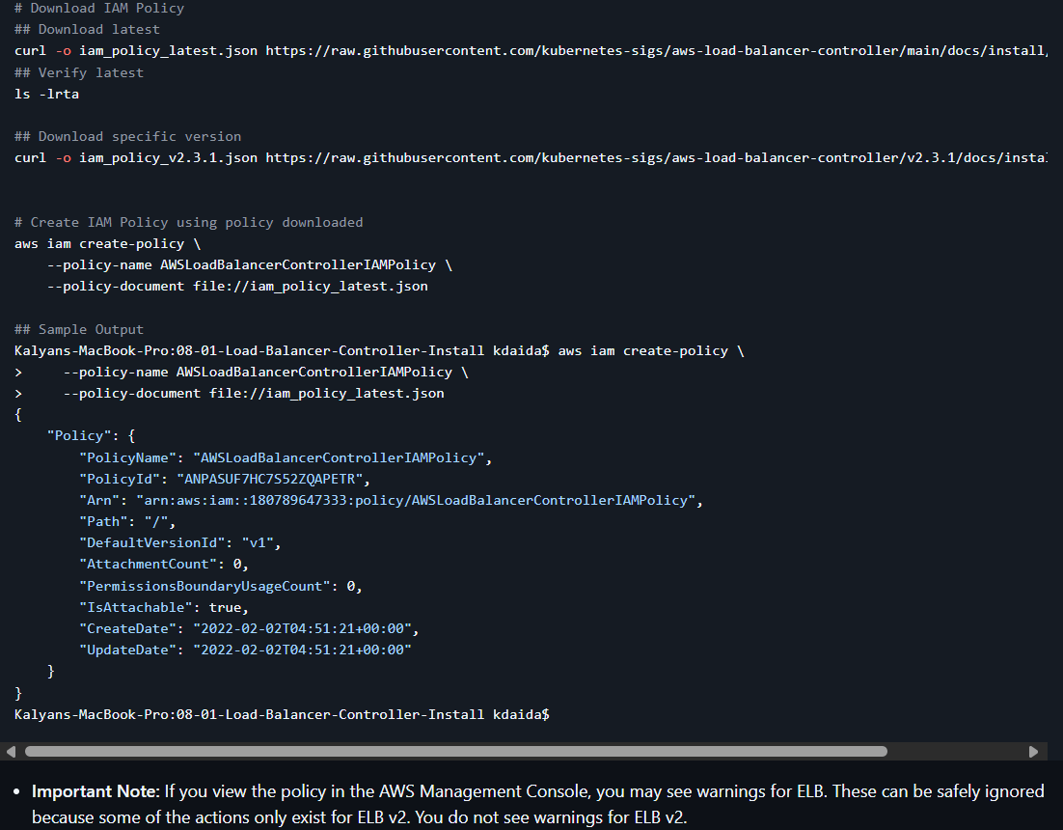
We are going to create a new policy by using the downloaded json file you can see in above ss.
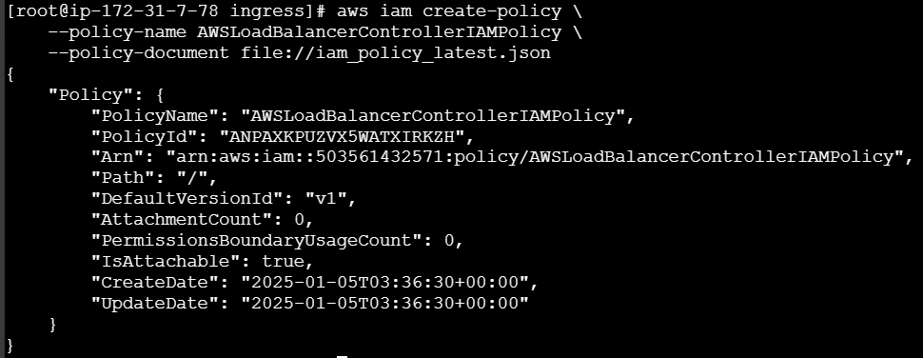
We have created the IAM policy through CLI using the downloaded json doc. Now make a note of ARN we are going to use the Policy ARN or you can collect it from AWS console by searching “AWSLoadBalancerControllerIAMPolicy” in policies section in IAM.
Create IAM Role along with K8s Service Account:-
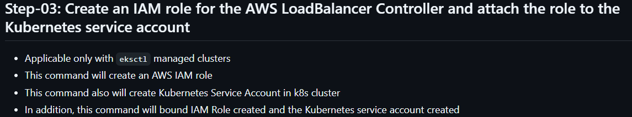
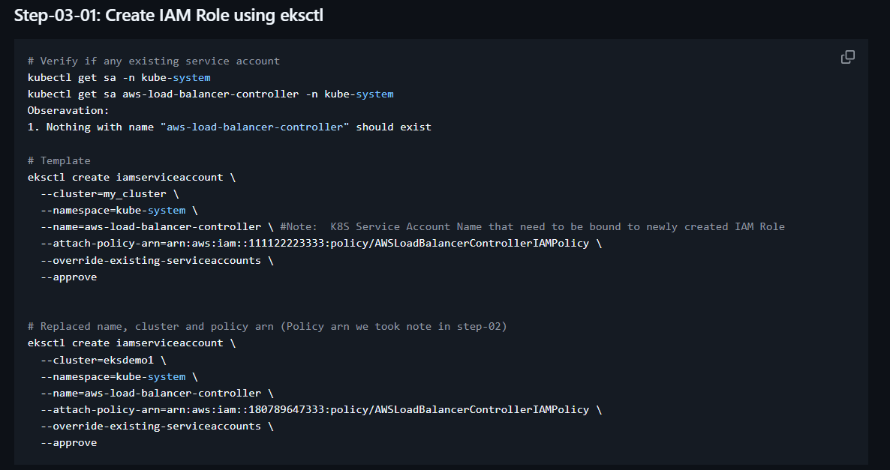
I ran the command with my ARN the sample output is.
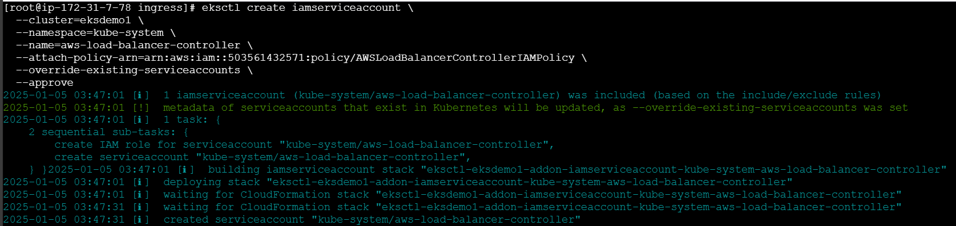
Verify role
If you see above ss at ROLE ARN you can find this ‘eksctl-eksdemo1-addon-iamserviceaccount-kube--Role1-YAhWl24pCSck’ that is nothing but a role which we have created.
Alternatively you can verify in cloud formation stack also.
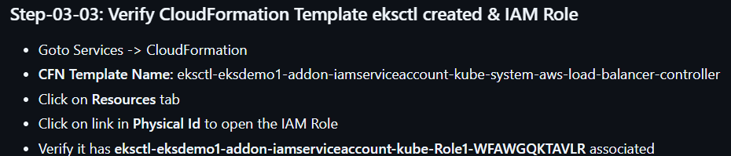
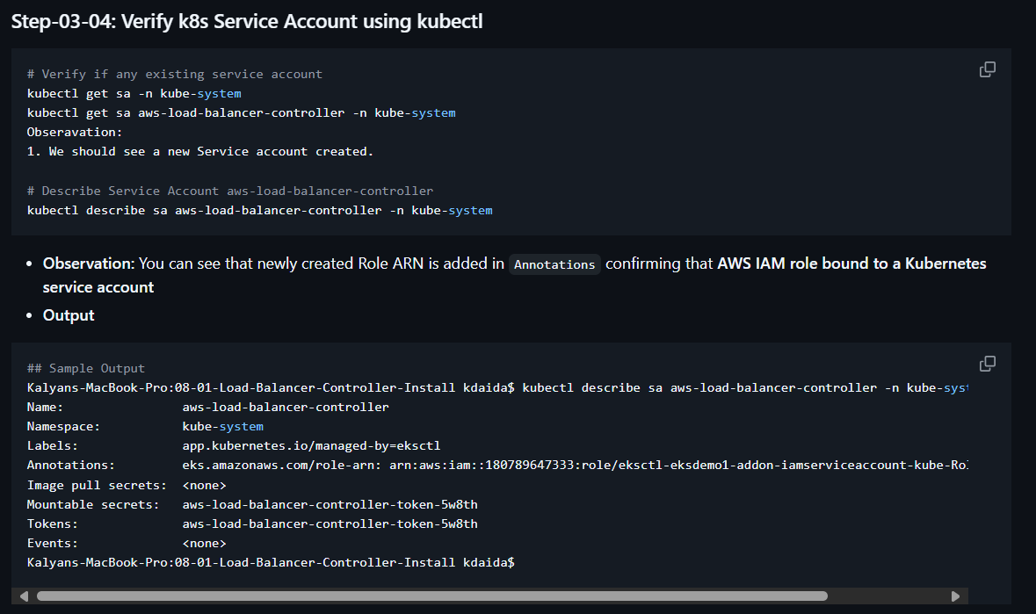
For me
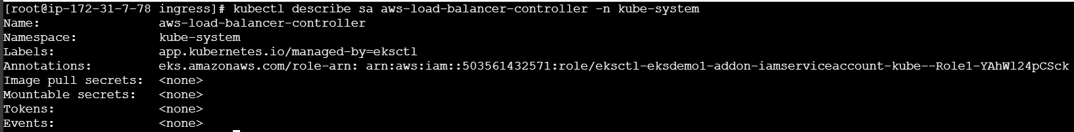
Install AWS LB Controller using Helm V3:-
As of now we have created the IAM Policy and attach it to an IAM role and annotated the role to LB Controller Service Account.
Now, our next step will be installing AWS LB Controller by using Helm V3.
First we need to install helm, for that use this doc Deploy applications with Helm on Amazon EKS - Amazon EKS and verify by running ‘helm version’.
***Important note:-
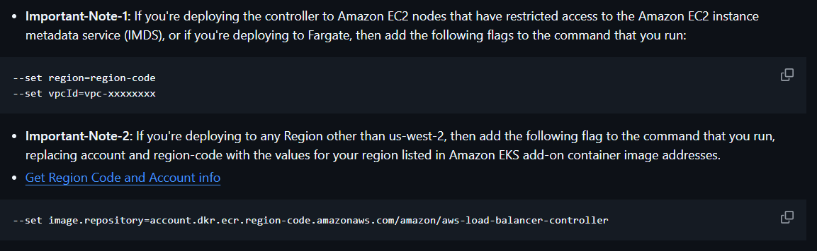
If you want to download the LB controller we have to define account and region separately for each region. Verify this doc for more info View Amazon container image registries for Amazon EKS add-ons - Amazon EKS the sample SS has added below.
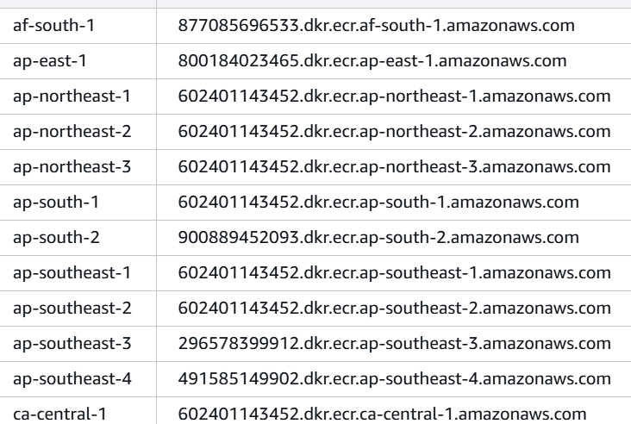

Here our region is ap-south-1 (Mumbai) I will use ‘602401143452.dkr.ecr.ap-south-1.amazonaws.com’.
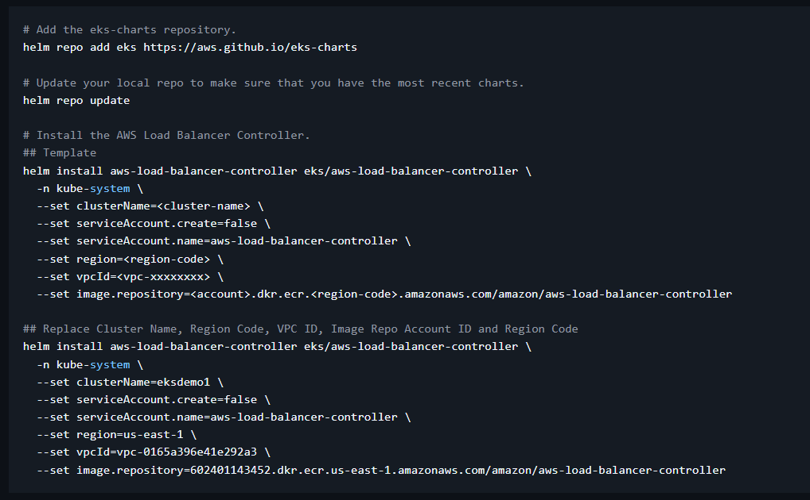
Run above commands with the updated values.
From above ss you can see ‘eks/aws-load-balancer-controller’ it’s refering to the repo. serviceAccount.create=false if we mention it as true it will create a new otherwise we have to define created by mentioning ‘false’ you can see in ss.
Collect the vpcId of our eks cluster and replace same for image.repository also update the values from this link View Amazon container image registries for Amazon EKS add-ons - Amazon EKS as per the region.
Now run the updated command the output is.
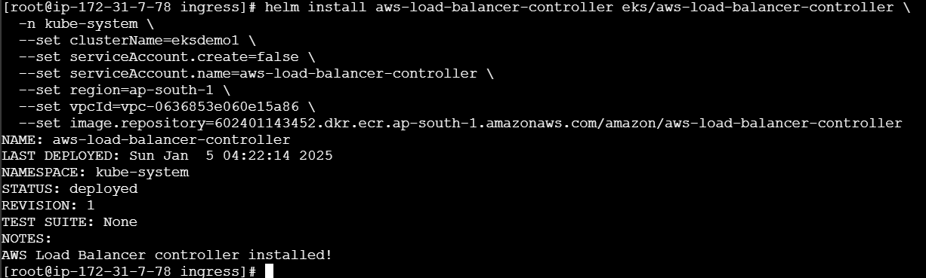
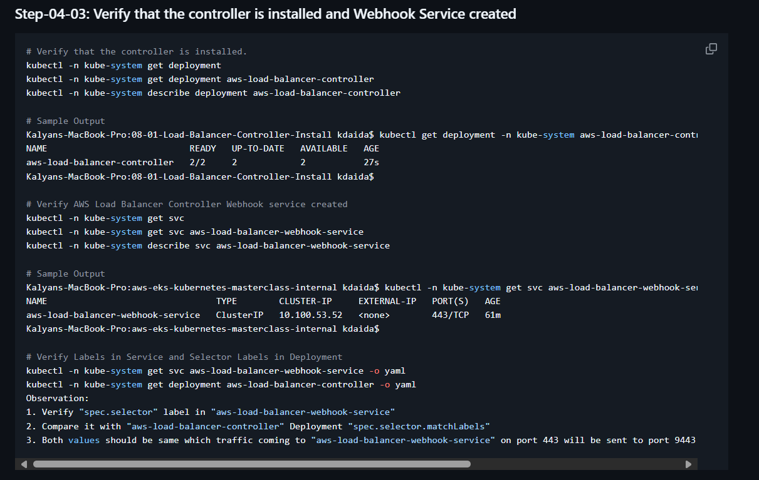
After running “kubectl -n kube-system describe deployment aws-load-balancer-controller” command you can see port 9443 our LB controller is running and type is SSL and it’s associated with TLS certificate as secret volumes “SecretName: aws-load-balancer-tls” under Volumes session.
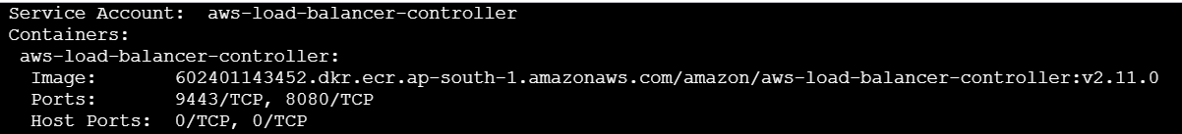
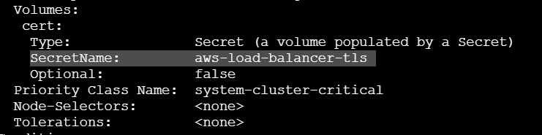
For AWS LB controller webhook.
The both webhook and the controller should match the label.
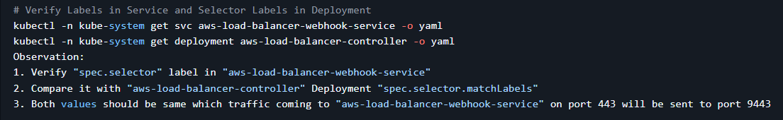
Observation:
1. Verify "spec.selector" label in "aws-load-balancer-webhook-service"
2. Compare it with "aws-load-balancer-controller" Deployment "spec.selector.matchLabels"
3. Both values should be same which traffic coming to "aws-load-balancer-webhook-service" on port 443 will be sent to port 9443 on "aws-load-balancer-controller" deployment related pods.
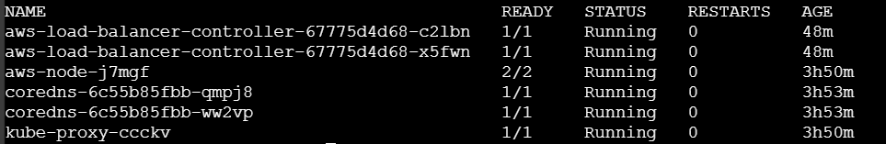
LB controller pods got created.
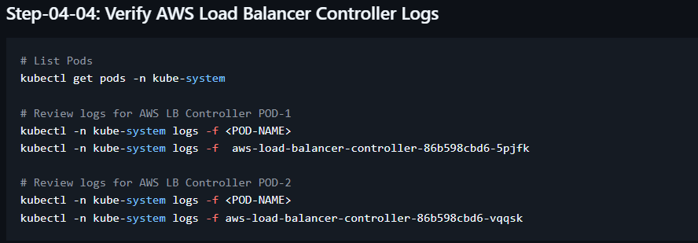
If you verify the LB controller POD logs you can see only ‘info’ not ‘error’.
Verify AWS Load Balancer Controller k8s Service Account – Internals (optional):-
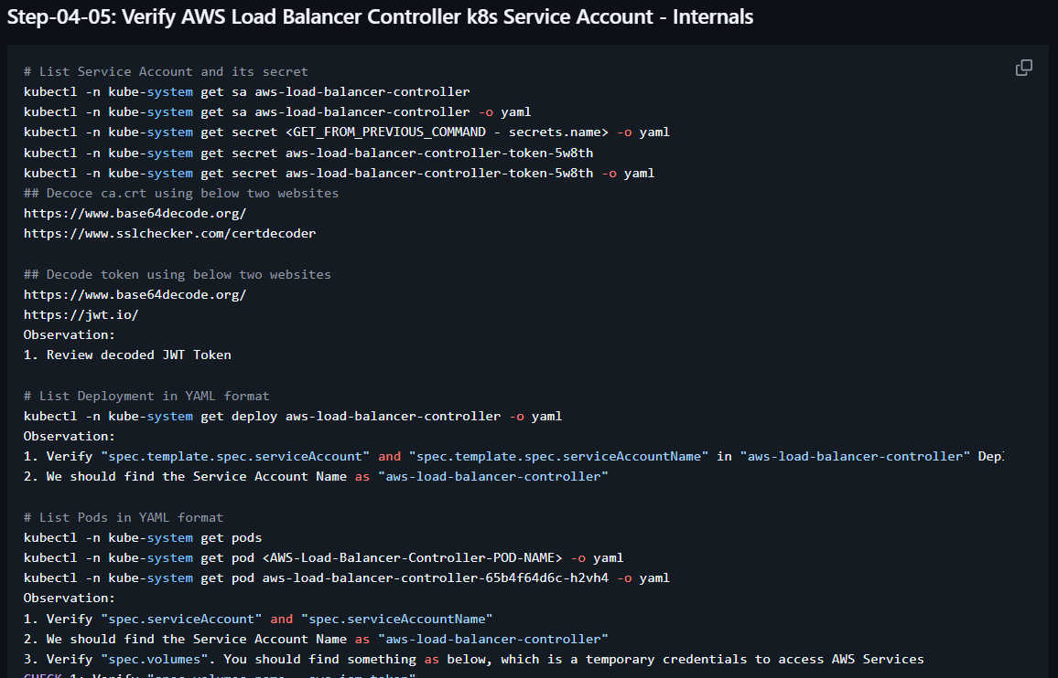
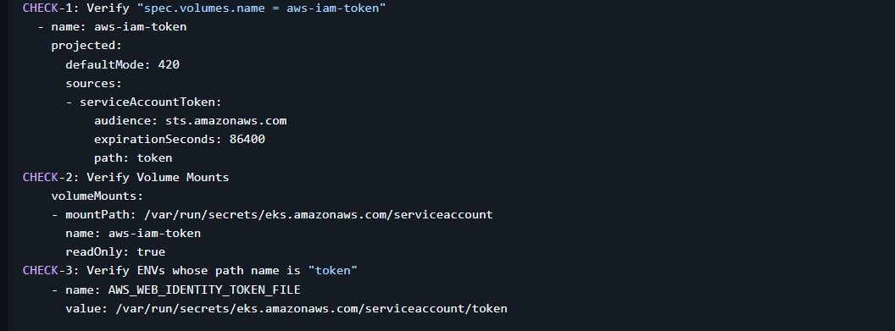
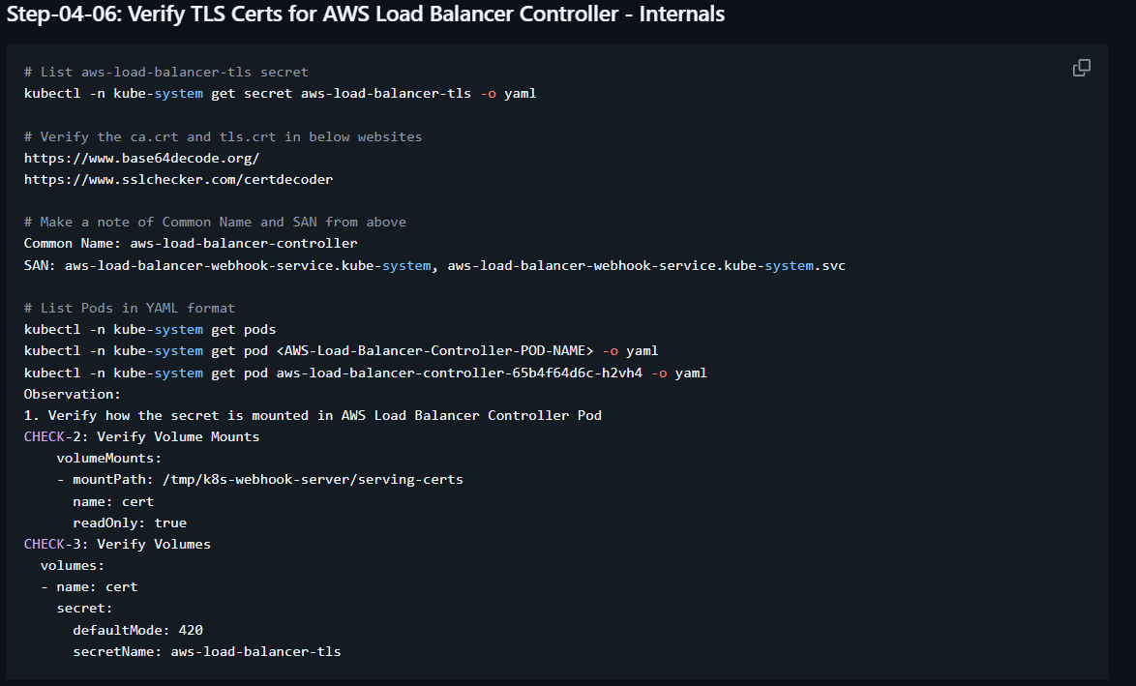
Note:- For me in ‘sa’ not showing ‘secret’ so had to skip the hands on session on this.

Kubernetes Ingress Class:-
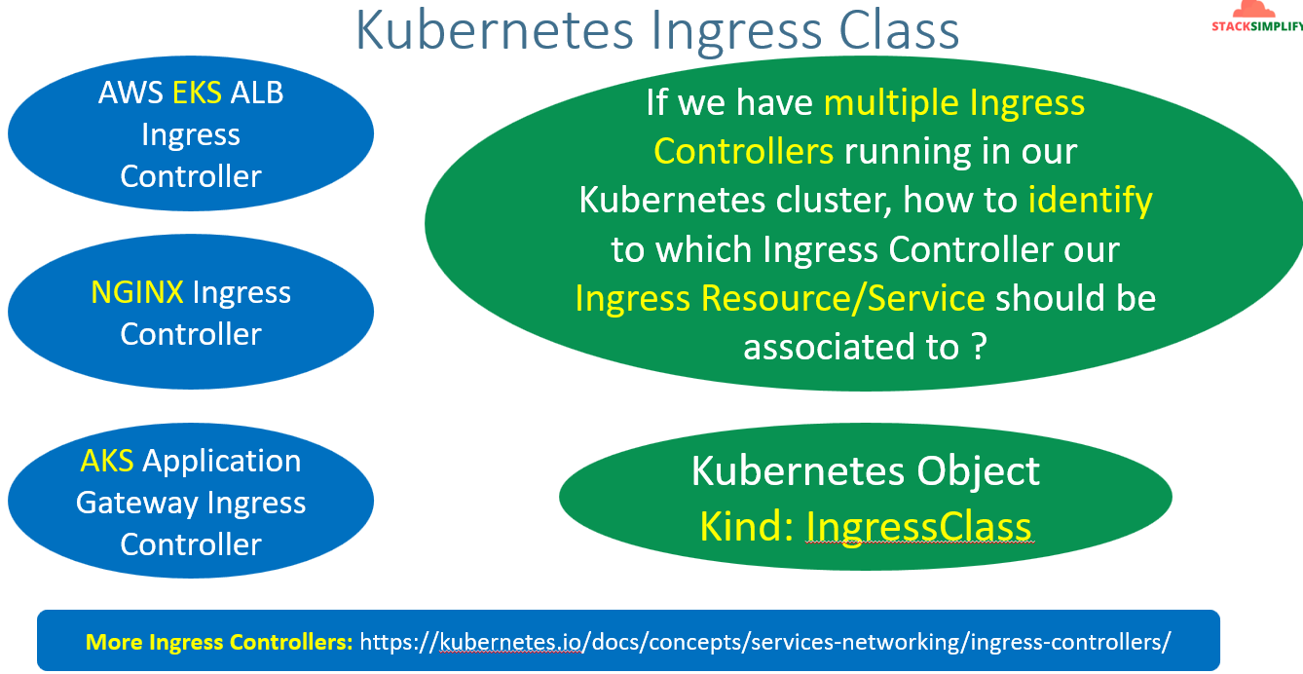
Ingress clas doc IngressClass - AWS Load Balancer Controller
Different types of Ingress controllers Ingress Controllers | Kubernetes.
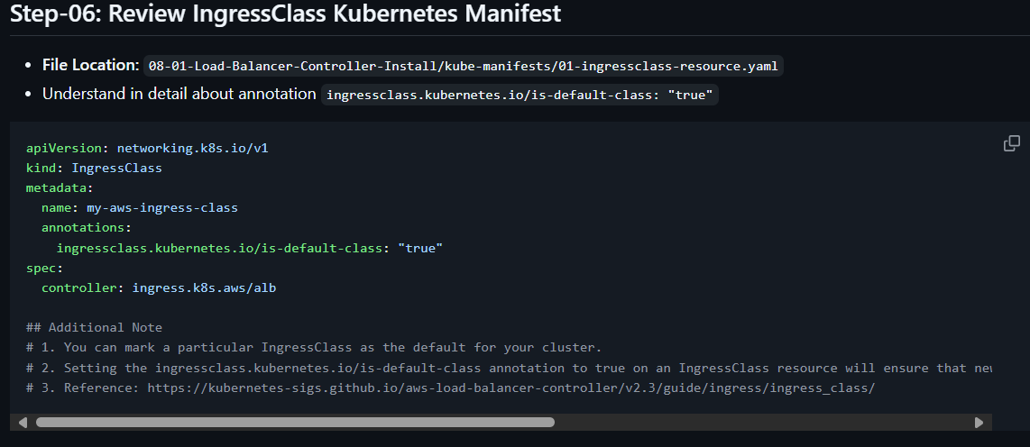
Here in IngressClass manifest we will define the ingress controller details under spec you can see from above ss in spec.controller. the name we defined for ingress class ‘my-aws-ingress-class’ ingress service will be associated to the defined controller.
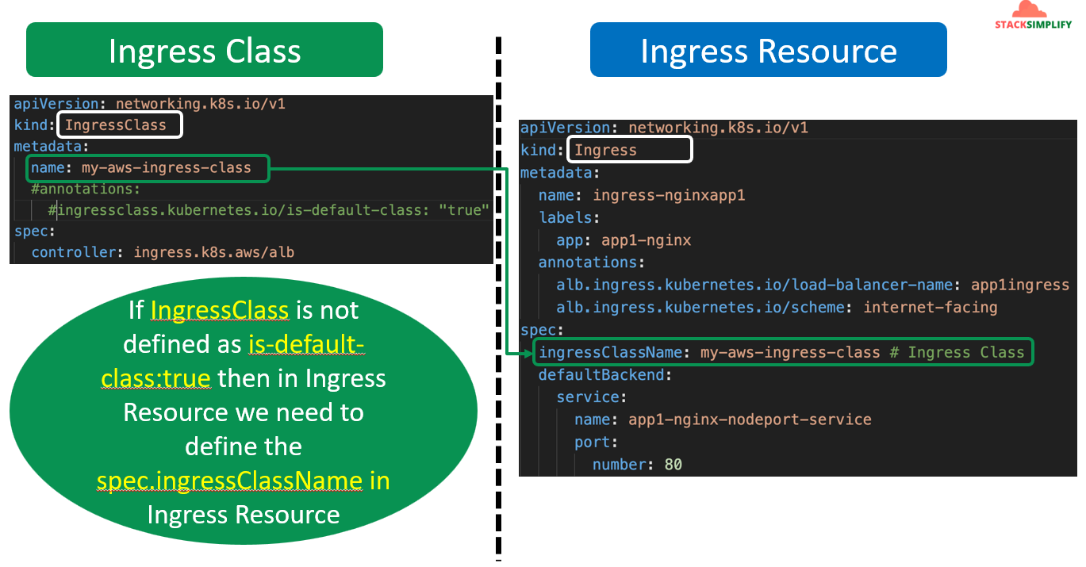
We have created the IngressClass successfully by running the manifest from step 6.
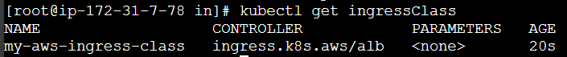
AWS LB Controller installation doc Route internet traffic with AWS Load Balancer Controller - Amazon EKS.

